Lesson 15

Input Boxes
An Input Box is a similar dialogue to the Message Box, which allows you to provide a text string to be edited by the user. This is very useful if you require values, which are textual or within a range which does not correspond to the standard values returned by a message box.

Example code:
Private Sub Command_Click()
Text1.Text = InputBox(“Enter your name...”, “Sample Input box”,“Your Name”, 200,200)
End sub
Produces the following
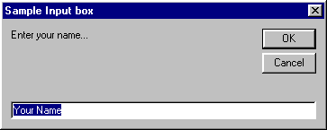
Where the text “Your Name” is a default value. And 200,200 are screen co-ordinates - if these are omitted the box is centred.
Create a form with buttons and TextBox in order to try this out, and look in the help system to find out more.

Uses for Input boxes and Message boxes
Input boxes are useful a set of data must be entered in a fixed sequence, which is then controlled by a set of code. The input box will wait for the information to be entered before continuing to the next.

Exercise
Write a program to prompt the user of the program for the following information in sequence.
The user should be asked for their name and then their date of birth. The program should add the name information into the date of birth prompt. Once the information is obtained use the date of birth to calculate the day of the week of birth. Test the program with today’s date and your Birthday.

